Appendix
A.1 Weigh-in and sintered compositions
Atomic composition of reactive sintered borides (RSB) and cemented tungsten carbides (cWCs) for (a) weigh-in compositions and (b) sintered compositions post ICP-EDX analysis. Additional data on sintered carbon content from Windsor et al (2018).
(a)
 | Weigh-in abundance at%
Composition | W | C | Fe | Cr | B
JBTE10 | 42.5 | 42.5 | 13.8 | 1.2 | 0
B1TE10 | 39 | 40.2 | 14.7 | 1.3 | 4.8
B4TE21W | 35.5 | 6.7 | 30.1 | 2.6 | 25
B5T522W | 30.3 | 7.7 | 28.8 | 2.5 | 30.8
B7TE23W | 26.5 | 9.2 | 26.6 | 2.2 | 35.4
B9TE25W | 22.1 | 10 | 25.5 | 2.2 | 40.1

(b)

 | ICP abundance at%
Composition | W | C | Fe | Cr | B
JBTE10 | 43.2 | 39.9 | 15.6 | 1.4 | 0
B1TE10 | 40.1 | 37.8 | 14.6 | 1.3 | 6.2
B4TE21W | 36.3 | 4.5 | 31 | 2.7 | 25.5
B5T522W | 29.9 | 7.4 | 27.4 | 2.4 | 32.9
B7TE23W | 28.4 | 4.8 | 28.4 | 2.5 | 36
B9TE25W | 25.7 | 6 | 29.7 | 2.6 | 36.1
(b)

 | Sintered abundance at% |  |  |  |  | C at%
Composition | W | C | Fe | Cr | B | After Windsor et al[2]
JBTE10 | 43.2 | 39.9 | 15.6 | 1.4 | 0 | -
B1TE10 | 40.1 | 37.8 | 14.6 | 1.3 | 6.2 | -
B4TE21W | 36.3 | 4.5 | 31 | 2.7 | 25.5 | -
B5T522W | 29.9 | 7.4 | 27.4 | 2.4 | 32.9 | 5.6
B7TE23W | 28.4 | 4.8 | 28.4 | 2.5 | 36 | 6.2
B9TE25W | 25.7 | 6 | 29.7 | 2.6 | 36.1 | 7.4

Table A1: (a) Weigh-in and (b) sintered atomic compositions for cWC and RSB samples.

A.2 XRD and phase identification
Total indexed phases determined from cWC and RSB samples from HRXRD diffraction. Percentages are given in terms of diffracted intensity. Relative abundances were used for calculating ρ_{XRD} from the sum of phase densities.

Phase |  | Phase abundance mol%
name | PDF number | JBTE10 | B1TE10 | B4TE21W | B5T522W | B7TE23W | B9TE25W
FeB₂W₂ | 04-001-6421 | 0.0 | 0.0 | 11.5(1) | 12.4(1) | 16.7(1) | 13.4(1)
FeWB | 00-032-0307 | 0.0 | 0.0 | 18.9(1) | 25.4(1) | 31.9(1) | 0.2(1)
W₂B₅ | 01-038-1365 | 0.0 | 5.6(1) | 3.0 | 1.5(1) | 7.6(1) | 18.4(1)
WB | 00-006-0541 | 0.0 | 0.0 | 10.2(1) | 13.0(1) | 9.3(1) | 13.0(1)
d-WB | 00-035-0738 | 0.0 | 0.0 | 1.3(2) | 0.6(1) | 0.4(1) | 0.0
WB₄ | 01-080-4747 | 0.0 | 0.0 | 0.2(1) | 2.1(1) | 0.3(1) | 0.1(1)
WC | 01-084-5996 | 81.9(2) | 74.7(2) | 2.0(1) | 9.7(1) | 5.1(1) | 5.3
Fe₂B | 04-013-1369 | 0.0 | 2.5(1) | 0.9(2) | 10.8(1) | 13.1(1) | 26.7(2)
FeB | 00-032-0463 | 0.0 | 0.0 | 1.1(2) | 0.0 | 0.0 | 2.6
FeCr | 00-054-0331 | 11.5(2) | 10.1(2) | 0.3(1) | 0.0 | 0.0 | 0.0
Fe₇W₆ | 00-003-0918 | 0.0 | 0.0 | 18.9(1) | 1.1(2) | 0.0 | 1.3(2)
Fe₂W | 00-003-0918 | 0.0 | 0.0 | 3.2(1) | 11.3(1) | 0.0 | 0.0
M₁₂C | 04-003-9466 | 5.6(1) | 4.4(1) | 0.9(2) | 1.6(1) | 8.2(1) | 7.6(1)
M₂₃C₆ | 04-013-6964 | 0.9(1) | 0.0 | 9.4(2) | 0.0 | 1.9(1) | 8.2(1)
W₂C | 04-014-5679 | 0.0 | 0.0 | 2.5(1) | 0.3(1) | 1.1(2) | 0.8(2)
W₂B | 00-035-0738 | 0.0 | 0.0 | 0.2(1) | 0.4(2) | 0.9(2) | 0.0
Fe₃C | 00-003-1055 | 0.0 | 0.0 | 0.9(1) | 3.8(1) | 1.4(2) | 0.2(1)
CrB | 00-032-0277 | 0.0 | < 0.1 | 0.2(1) | 2.5(1) | 0.6 | 0.0
Cr₃C₂ | 00-035-0804 | 0.0 | 0.0 | 0.0 | 1.2(1) | 1.2(1) | 0.1(1)
Cr₅B₃ | 00-032-0278 | 0.0 | 0.0 | 0.0 | 0.2(1) | 0.1(1) | 0.0
Cr₂B | 00-038-1399 | 0.0 | 0.0 | 1.2(1) | 0.5(1) | 0.2(1) | 0.0
 | Total indexed phases: | 4 | 5 | 19 | 18 | 17 | 14
 | phases ≥ 1% | 3 | 4 | 12 | 13 | 11 | 9

Table A2: Phases in TOPAS, their PDF numbers and their relative abundance in mol% in RSB materials. Uncertainties are in brackets (e.g 31.9(2)% = 31.9 ± 0.2%).

A.3 Differences in ICP-EDX and XRD composition in atomic %
Differences in calculated atomic abundance between ICP-EDX and XRD phase determination. Graphs were generated for each composition from (ICP-EDX)at% - (XRD)at% for each atomic species.

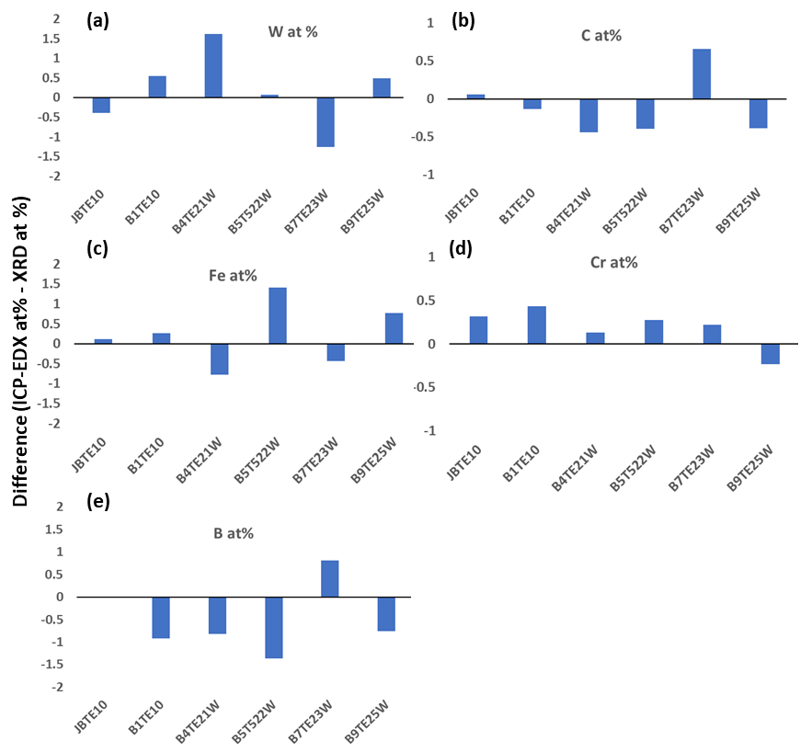
Figure A1: Differences in at% for atomic species between XRD models and ICP-EDX measurements of cWC and RSB compositions. a W, b C, c Fe, d Cr and e B.

