**Dilly et al. Supplementary Information**

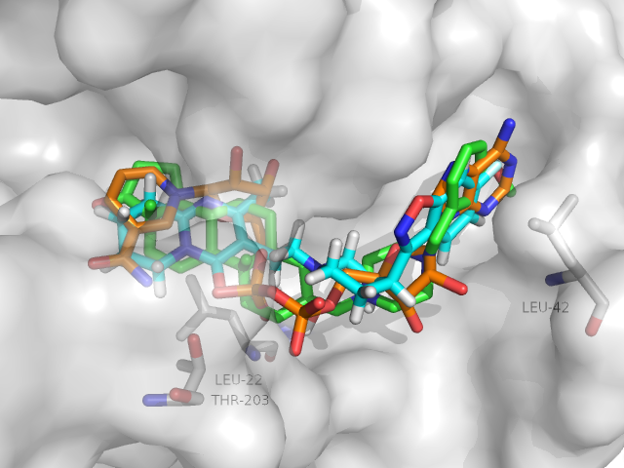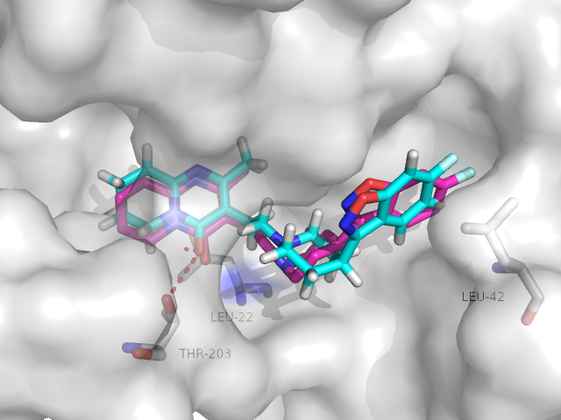

Figure S: a) Overlay of risperidone (cyan), RM-532-46 (green) and NAD co-factor (orange), modelled in the active site of 17-HSD10 (PDB-ID: 1U7T); b) Overlay of risperidone docked with Glide (cyan) and AutoDock (pink).

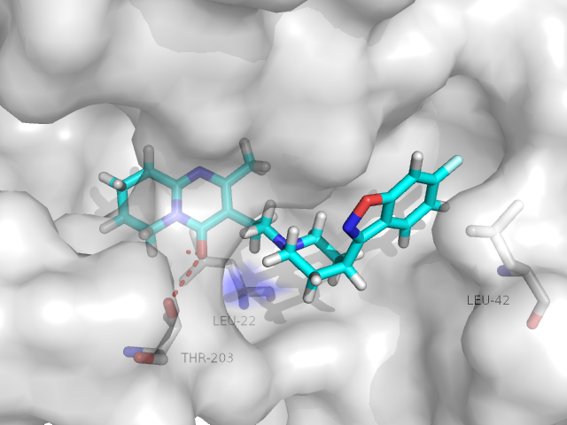

Figure S: 3D spatial binding representation of risperidone modelled in 17-HSD10 (PDB-ID: 1U7T)

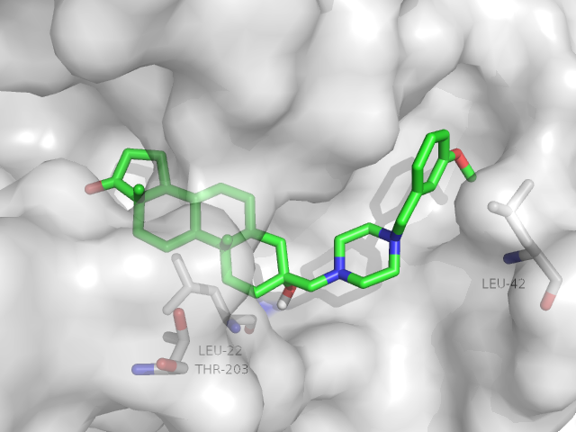

Figure S: 3D spatial binding representation of RM-532-46 modelled in 17-HSD10 (PDB-ID: 1U7T)

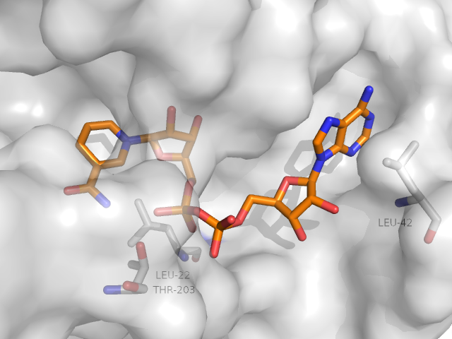

Figure S: 3D spatial binding representation of the NAD co-factor modelled in 17-HSD10 (PDB-ID: 1U7T)

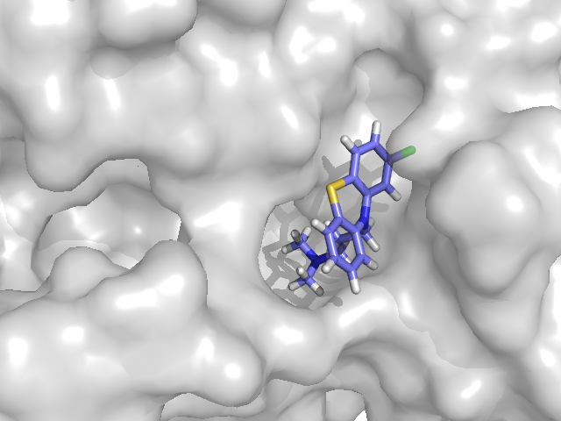

Figure S: 3D spatial binding representation of chlorpromazine modelled in 17-HSD10 (PDB-ID: 1U7T)

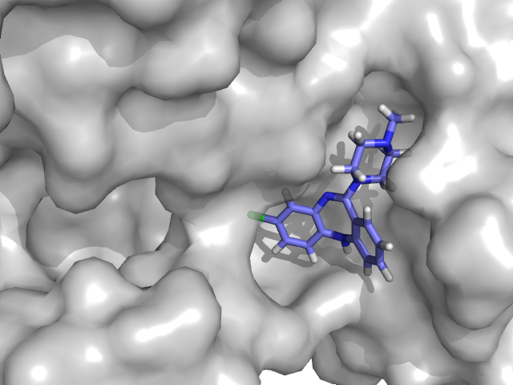

Figure S: 3D spatial binding representation of clozapine modelled in 17-HSD10 (PDB-ID: 1U7T)



Figure S: 3D spatial binding representation of clomipramine modelled in 17-HSD10 (PDB-ID: 1U7T)

Table : Glide and AutoDock scores for docking in the presence and absence of water and the NAD cofactor

|  |  |  |  |
| --- | --- | --- | --- |
| **Enzyme** | **Substrate** | **Glide Score** | **AutoDock Score** |
| **NAD and water present** | Risperidone | -5.197 | -9.59 |
|  | RM-532-46 | -4.227 | -9.00 |
|  | AG18051 | -7.298 | -7.53 |
| **NAD present, no water** | Risperidone | -4.798 | -9.49 |
|  | RM-532-46 | -5.071 | -9.20 |
|  | AG18051 | -3.657 | -7.70 |
| **No NAD or water** | Risperidone | -8.037 | -10.88 |
|  | RM-532-46 | -6.014 | -13.92 |
|  | AG18051 | -7.115 | -8.25 |
|  | NAD co-factor | -12.495 | -13.60 |

Although different in their absolute values (to be expected due to the different algorithms used in both programmes), the broad trends observed within theGlide docking scores generally show a reasonable correlation with those obtained using AutoDock 4.2. For all three substrates the highest scores (corresponding to the tightest predicted binding of ligands within the protein) are seen with both Glide and AutoDock when there is no water or NAD co-factor present in the crystal structure. The NAD co-factor was also re-docked to show the binding score of the native ligand. The broad correlation found, may reflect, in part, a competitive binding between the compounds and the NAD co-factor. Interestingly, AutoDock gives a somewhat different score to Glide when docking RM-532-46 which would appear to reflect the observation that AutoDock places this molecule deep into the active site pocket whereas Glide produces a more shallower docking pose and places part of the molecule out into the solvent exposed region.

Table : Binding scores of different substrates to the 17HSD10 enzyme (PDB-ID: 1U7T)

|  |  |  |  |
| --- | --- | --- | --- |
| **Enzyme** | **Substrate** | **Glide Score** | **AutoDock Score** |
| **No NAD or water** | Risperidone | -8.037 | -10.88 |
|  | Chlorpromazine | -4.469 | -6.99 |
|  | Clozapine | -4.474 | -8.62 |
|  | Clomipramine | -5.402 | -7.46 |

In summary, the overall trends apparent within the Glide docking scores generally show a good correlation with the docking scores obtained using AutoDock 4.2 with the exception of clozapine. Risperidone is p to be the best binding compound in terms of both AutoDock and Glide scores. AutoDock provided a higher score than Glide when docking clozapine which is due to AutoDock placing the substrate deep into the active site pocket whereas Glide places part of the molecule out into the solvent exposed region.

**Docking protocol**

The *in silico* docking studies were conducted using Glide and AutoDock as previously described5 and as summarised below:

1. The crystal structure of the target protein 17-HSD10 was downloaded from the Protein Databank. (PDB ID: 1U7T)
2. The active site was defined using maestro.4 A 20 Å cut of the protein surrounding the active (a grid box of 80 x 80 x 80 was used in both programmes) site was designated as the protein receptor.
3. Risperidone, chlorpromazine, clozapine, clomipramine, RM-532-46, AG18051 and the NAD co-factor were constructed in maestro.4 The resulting structures were then fully energy minimised using the multiple minimisation tool (MM).
4. Each compound was then docked into the active site of 17-HSD10 using Glide. Ten dockings were conducted for each compound.
5. Glide scores were taken of the resulting docking ‘poses.’
6. The docking results were also independently assessed via repeating the docking procedure again using AutoDock 4.2 which utilises a Lamarckian genetic algorithm. Ten dockings were conducted for each compound.
7. The resulting docking ‘poses’ were scored using the AutoDock scoring function.

**Nucleotide sequences** from the Magic Tag® screen will be published at flybase.org

**References**

1. Kissinger, C. R.; Rejto, P. A.; Pelletier, L. A.; Thomson, J. A.; Showalter, R. E.; Abreo, M. A.; Agree, C. S.; Margosiak, S.; Meng, J. J.; Aust, R. M.; Vanderpool, D.; Li, B.; Tempczyk-Russell, A.; Villafranca, J. E., Crystal structure of human ABAD/HSD10 with a bound inhibitor: implications for design of Alzheimer's disease therapeutics. *J. Mol. Biol.* **2004,** *342* (3), 943-952.

2. (a) Goodsell, D. S.; Morris, G. M.; Olson, A. J., Automated docking of flexible ligands: Applications of AutoDock. *J. Mol. Recognit.* **1996,** *9* (1), 1-5; (b) Morris, G. M.; Huey, R.; Lindstrom, W.; Sanner, M. F.; Belew, R. K.; Goodsell, D. S.; Olson, A. J., AutoDock4 and AutoDockTools4: Automated Docking with Selective Receptor Flexibility. *J. Comput. Chem.* **2009,** *30* (16), 2785-2791.

3. (a) Friesner, R. A.; Banks, J. L.; Murphy, R. B.; Halgren, T. A.; Klicic, J. J.; Mainz, D. T.; Repasky, M. P.; Knoll, E. H.; Shelley, M.; Perry, J. K.; Shaw, D. E.; Francis, P.; Shenkin, P. S., Glide: A new approach for rapid, accurate docking and scoring. 1. Method and assessment of docking accuracy. *J. Med. Chem.* **2004,** *47* (7), 1739-1749; (b) Halgren, T. A.; Murphy, R. B.; Friesner, R. A.; Beard, H. S.; Frye, L. L.; Pollard, W. T.; Banks, J. L., Glide: A new approach for rapid, accurate docking and scoring. 2. Enrichment factors in database screening. *J. Med. Chem.* **2004,** *47* (7), 1750-1759.

4. Maestro, version 9.3, Schrödinger, LLC, New York, NY.

5. van Berkel, S. S.; Brem, J.; Rydzik, A. M,; Salimraj, R.; Cain, R.; Verma, A.; Owens, R. J.; Fishwick, C. W. G.; Spencer, J.; Schofield, C. J. An Assay Platform for Clinically Relevant Metallo-β-Lactamases*. J. Med. Chem*, **2013**, *56*(17), 6945 – 6953.